

The Pavilion, Broomhall Lane, Sunningdale, SL5 0QS

1. 01344 874268

Email: info@sunningdaleparish.org.uk

[www.sunningdale-pc.org.uk](http://www.sunningdale-pc.org.uk)

Clerk: Ruth Davies

Briony Franklin

Royal Borough of Windsor and Maidenhead

Town Hall, St Ives Road

Maidenhead, Berks SL6 1RF

26 March 2021

Dear Briony,

**21/00765 8 Hamilton Drive Sunningdale Ascot SL5 9PP  
Replacement dwelling incorporating the existing garage**

Whilst many of the houses within Hamilton drive have been extended this has been undertaken with an overall regard to the street scene to ensure a compatible design with the neighbouring properties. The photograph below showing the surrounding houses within the road. The overall design approach demonstrates a uniformity therefore creating a townscape and street scene that is harmonious.

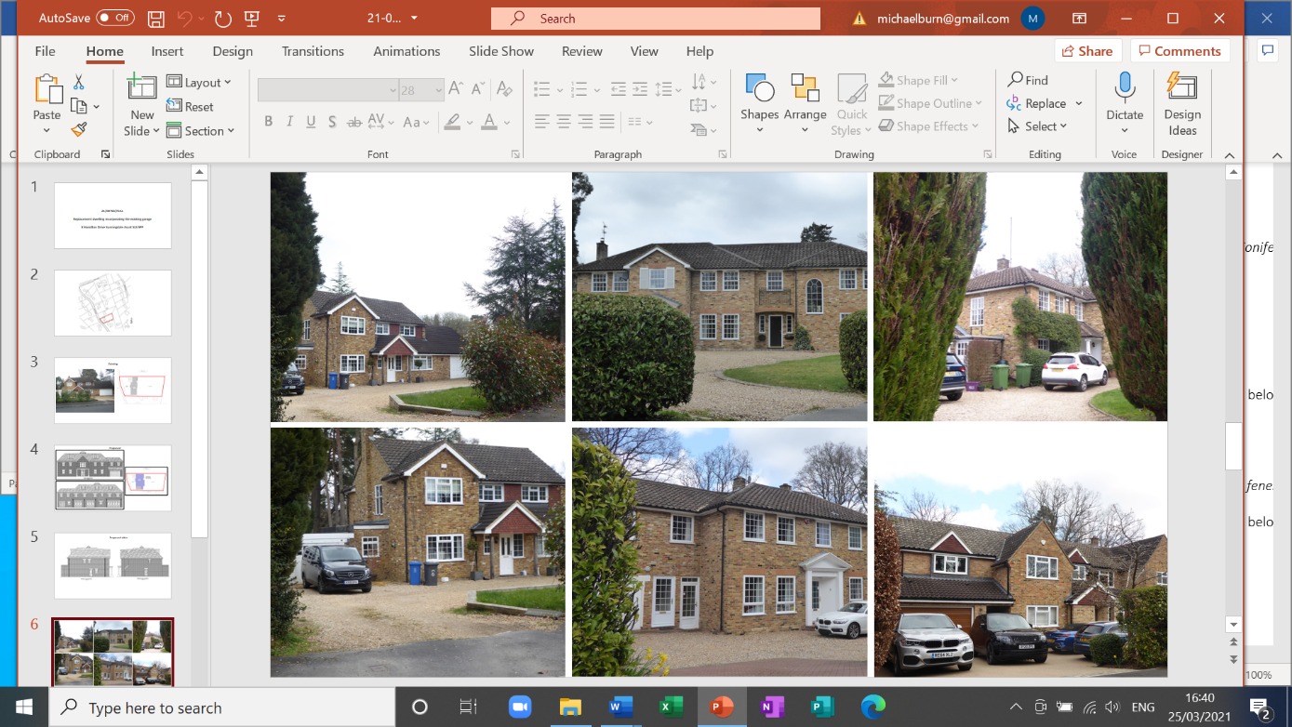

**Street scene**

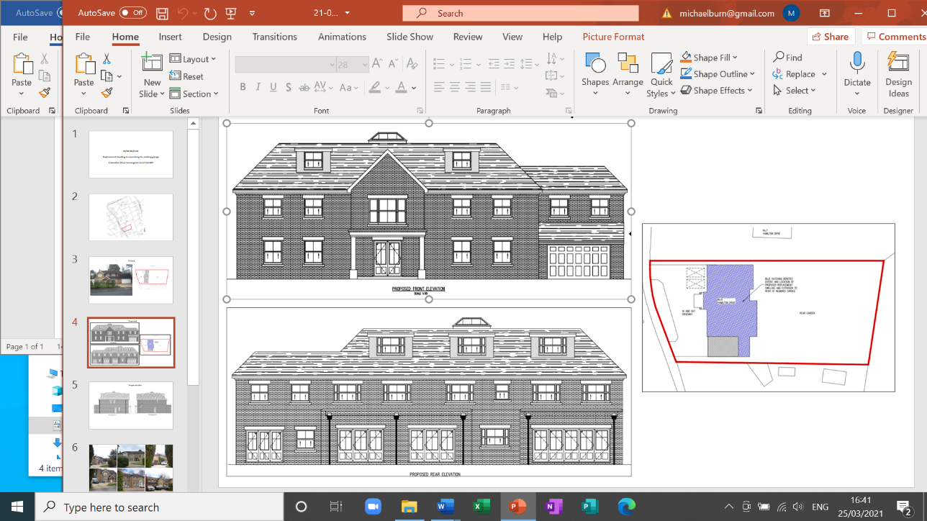The Parish Council is concerned that the proposed design, shown below, occupies the entire width of the plot over a full two storeys. The overall design is very different to neighbouring properties. No other house in Hamilton Drive that we are aware of has dormer windows and accommodation over 3 floors. There is an overall impression of dominating the plot and being at variance with the street scene. It is unfortunate that the applicant has not stated any actual heights for the building or supplied any drawings or pictures indicating the height and size of the proposed building in comparison to the other houses in the street. The size, bulk and scale of the proposed building can be seen below.

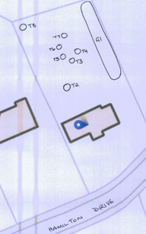**TPO Trees**

It is noted that an earlier application on the same site (17/01172), by the same applicant, requested works to TPO trees. This was approved in June 2017. The proposed new build extends further into the site and would therefore be closer to tree T2. However, some clarification is required regarding the distance of the proposed new build from the RPA and canopy of tree T2. Shown below is the diagram that was submitted under 17/01172 showing the position of T2. We could see little or no reference to the trees on the site in 21/00765

The Parish Council **Objects** to this application.

On behalf of the council,

Cllr Yvonne Jacklin and Cllr Michael Burn

Co-chairs of Planning