

The Pavilion, Broomhall Lane, Sunningdale, SL5 0QS

1. 01344 874268

Email: info@sunningdaleparish.org.uk

[www.sunningdale-pc.org.uk](http://www.sunningdale-pc.org.uk)

Clerk: Ruth Davies

Jo Richards

Royal Borough of Windsor and Maidenhead

Town Hall, St Ives Road

Maidenhead, Berks SL6 1RF

26th June 2020

Dear Jo,

**20/01294/FULL Sunningdale Villas London Road Sunningdale Ascot**

**Construction of x6 orangeries.**

This application would appear to be identical to the withdrawn application 19/03320 and the Parish Council continues to **strongly object** to all three applications for this site, which are still awaiting decision.

Application 1: **19/03244/VAR** | Variation (under Section 73) of condition 19 (approved plans) to substitute those plans approved under 17/02204/FULL for the construction of a building to provide x 8 two bed flats, together with access to London Road and landscaping, following demolition of the existing buildings. | Site of Bluebells Restaurant and Bar London Road Sunningdale Ascot

Application 2: **19/03266/FULL** | New single garage for plot 5. | Sunningdale Villas London Road Sunningdale Ascot

Application 3: **20/01294/FULL** | Construction of six new Orangeries. | Sunningdale Villas London Road Sunningdale Ascot

These various planning applications individually and in total attempt to expand the scope of the approved scheme for the 8 two-bedroomed apartments (17/02204)

**Green belt – Openness**

This site sits in the Green Belt. The permitted development of eight two-bedroom flats was acceptable because of the reduced scale and massing and the lesser impact on the openness of the Green Belt than the originally proposed ten two-bedroom scheme.

A key element of achieving this acceptable level of openness was the reduction in the spread of development across the site. When considered along with the decrease in volume of development, *‘the final set of amended plans for application 17/02204 were considered not to have a greater impact on the openness of the Green Belt than the existing development’.*

The data used to make this assessment was the increase in floor space (GEA) of 1.5% from 1076.5 m2 to 1092.5 m2 which was acceptable given that the volume comparison showed an overall reduction in volume across the site of from 4248 m3 to 4098 m3 (Ref: 16-P1306-500C)

**Application 20/01294**

The current application is for six new Orangeries which are shown in the site plan below.

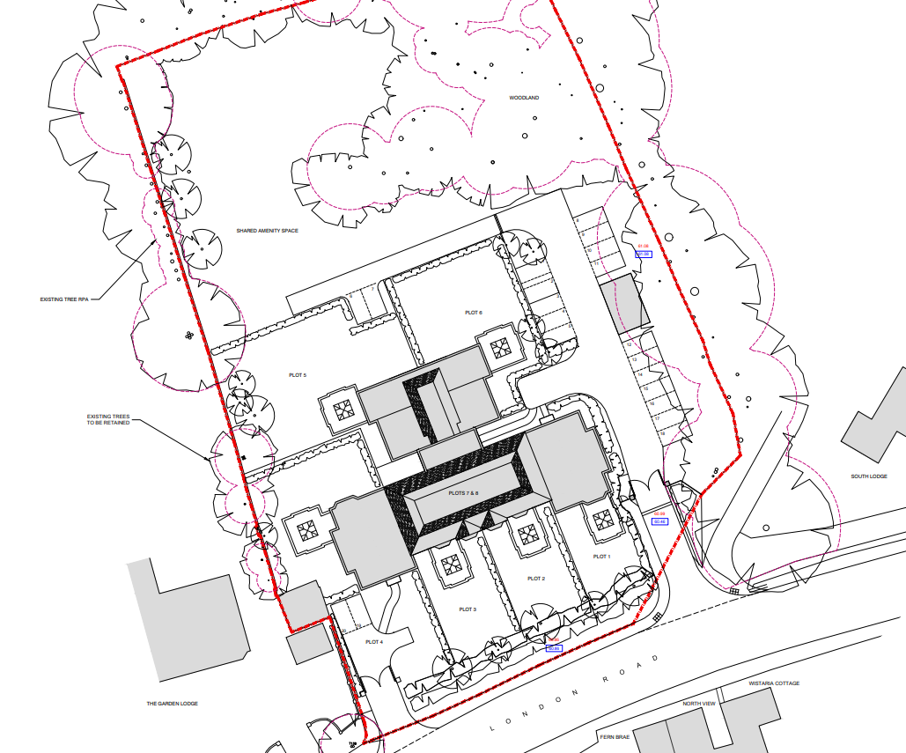

It is useful to compare what is now being proposed with what was originally on the site to see the significance of the changes to the Green Belt that are now being proposed.

Below is a site layout of the original Bluebells restaurant taken from 17/02204

site layout of the original Bluebells restaurant taken from 17/02204

**Original Bluebells Restaurant, (Drawing 16 P1306-503)**

Original Bluebells restaurant site measurements (square metres), Drawing 16 P1306-

**Original Bluebells restaurant site measurements (square metres), Drawing 16 P1306-504**

The volume chart above shows the considerable volume (primarily building E) at the rear of the original site that was really hidden from public view but formed an important component of the original site volume against which comparisons were made for the new building. Interestingly Building E comprised 34% of the GIA of the entire site.

Original Bluebells restaurant site volume, Drawing 16 P1306-500

**Original Bluebells restaurant site volume, Drawing 16 P1306-500**

The approved scheme moved all the volume of the site closer to the front boundary which has therefore had a significant impact on the Green Belt as viewed by the public from the London Road.

The addition of six extensions in the form of orangeries, all of which are habitable space will add significantly to the area and volume of the site and therefore the openness of the Green Belt.

This is demonstrated in the comparison between the elevations for the approved scheme (17/02204) below.

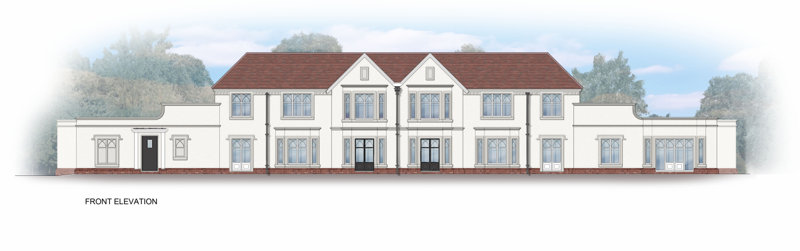

And the current application 20/02194.

current application 20/02194

Below is a picture of the front of the original Bluebells restaurant.

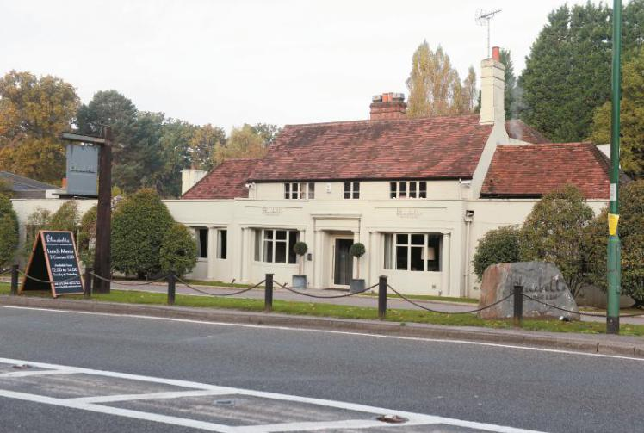

**Conclusion**

The difference in mass, size, bulk and scale of the proposed new building with the additional 6 orangeries is in marked contrast to the original Bluebells restaurant. The Parish Council believe that the volume of the original Building E at the rear of the property as well as the submission of successive variations to 17/02204 has positioned all the allowable construction towards the front of the site which has had a significant impact on the Green Belt.

This has had the effect, as outlined above, of severely affecting the openness of The Green Belt.   
Comparing the front elevations of the original Bluebells restaurant with the new proposed 8 apartments and 6 orangeries it is hard to come to any other conclusion than the openness of the Green Belt has been compromised.

Paragraph 89 of the National Planning Policy Framework (NPPF) allows for redevelopment within the Green Belt ‘***which would not*** ***have a greater impact on the openness of the Green Belt and the purpose of including land within it than the existing development.’***

The Parish Council believe 20/01294 is in conflict with paragraph 89 of the NPPF and we would strongly request that RBWM **REFUSE** this application.

Regards

Yvonne Jacklin and Michael Burn

Co-Chairs of Planning