

The Pavilion, Broomhall Lane, Sunningdale, SL5 0QS

1. 01344 874268

Email: info@sunningdaleparish.org.uk

[www.sunningdale-pc.org.uk](http://www.sunningdale-pc.org.uk)

Clerk: Ruth Davies

Paul Cross

Royal Borough of Windsor and Maidenhead

Town Hall, St Ives Road

Maidenhead, Berks SL6 1RF

25th June 2020

Dear Paul,

**20/01152/TPO Wilton House 13 Sunning Avenue Sunningdale Ascot SL5 9PN**

**(T1) Sweet chestnut -fell (TPO 27 of 2005).**

The extant scheme on this site (18/02310) is for a new detached garage and new vehicular access.

The applicant states under this application (20/01152) that the garage has been built and includes this photo below where the red type states ‘Garage recently built here’.

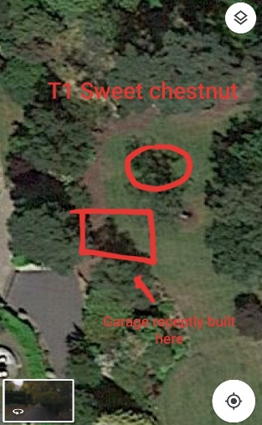

This application requests the felling of T1 as shown in the application drawing below, which is of poor quality and no photographs are included of the tree itself, even though the application form states ‘***fell because of significant die back (see photos).’***

There is also no accompanying independent arboricultural report stating the condition of the tree.

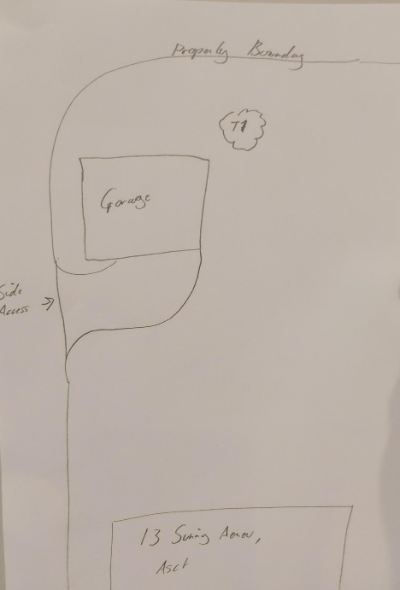

An earlier application for this garage (17/03518) was refused by RBWM for the following reason:

***‘The site is within a wooded area covered by TPO 27/2005. This TPO area significantly contributes to the sylvan characteristics of the locality and has a high amenity value. The proposal would require the removal of trees to allow construction of the proposed building. Furthermore, given the size of the building (floor area of 195sq metres) it is likely that future works to trees would be requested due to debris falling from remaining trees within the location of the building.’***

The garage was then repositioned and approved under planning application **18/00513** and again subsequently under application **18/02310** as shown on the Property History below.

**Property History**

Listed development history for the property from RBWM planning portal

Detailed block plans have also been submitted from previous applications showing the retention of these TPO trees as shown in the plan below.

***Block plans from previous applications showing the retention of the TPO trees***

**artistic drawing of plans with proposed tree**

Given the history on this site the Parish Council recommend this application is **REFUSED** and that the applicant submits a professional independent assessment of the condition of the tree.

The Tree Team may also want to visit the site and perhaps request an up to date photograph showing the position of the completed garage and its positioning relative to the TPO trees on the site.

Regards

Yvonne Jacklin and Michael Burn

Co-Chairs of Planning