

The Pavilion, Broomhall Lane, Sunningdale, SL5 0QS

1. 01344 874268

Email: info@sunningdaleparish.org.uk

[www.sunningdale-pc.org.uk](http://www.sunningdale-pc.org.uk)

Clerk: Ruth Davies

Zishan Pervez

Royal Borough of Windsor and Maidenhead

Town Hall, St Ives Road

Maidenhead, Berks SL6 1RF

27th April 2020

Dear Zishan,

**20/00750 Hare Wood, 9 Pinecote Drive, Sunningdale, Ascot SL5 9PS**

**New retaining wall to the ground floor front elevation, new front feature gable, part single part two storey part first floor side extension, single storey rear extensions and alterations to fenestration**

The Planning Committee **objects** to this application.

This is a substantial extension and the proposed plans of the ground floor show there is an oak tree in a public position in the front garden between properties 8 and 9. As shown in the picture below:

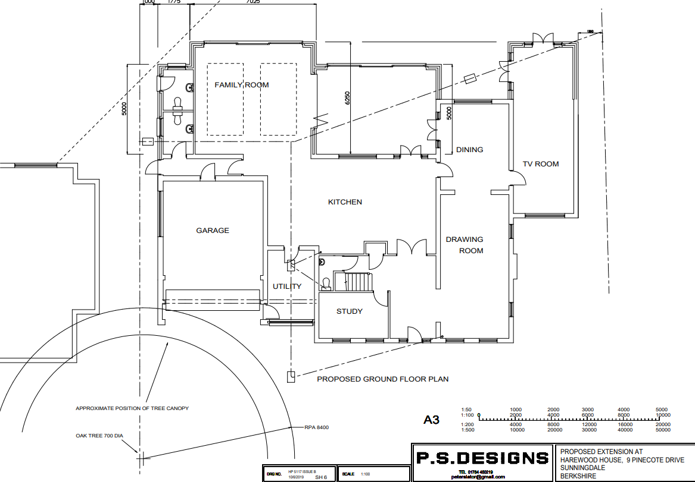

The existing garage is positioned outside of the RPA of that oak tree and is also a single storey. The proposed garage has now been positioned significantly further forward on the plot and there is now habitable accommodation planned on the second floor above the garage.

Therefore, not only does the new garage boundary wall impact on the oak tree RPA but there must be additional excavations both laterally towards the tree and deeper into the ground for the foundations of the new two storey building.

There is no accompanying arboricultural report and little or no indication given about the size, age and condition etc of the oak tree.

The Parish Council therefore request this application be **REFUSED**.

Regards

Yvonne Jacklin and Michael Burn

Co-Chairs of Planning