

The Pavilion, Broomhall Lane, Sunningdale, SL5 0QS

1. 01344 874268

Email: info@sunningdaleparish.org.uk

[www.sunningdale-pc.org.uk](http://www.sunningdale-pc.org.uk)

Clerk: Ruth Davies

Paul Cross

Planning Officer

RBWM

Town Hall

Maidenhead

26 March 2020

Dear Paul

**20/00616/TPO: 4 Wyldewoods Hancocks Mount Ascot SL5 9RB**

**(T1) - Chestnut - fell, (T2, T3) - Beech - Crown lifting up to 5m from ground level (TPO 3 of 1990).**

In section 7 of the TPO application form it is stated that the reason given for felling the Chestnut tree (T1) is that ‘*Recent poor pruning has resulted in poor form’.*

However, the accompanying ‘Property History’ form does not show any recent TPO application to RBWM requesting any TPO tree works so we were unsure how this pruning of a TPO tree was sanctioned. Also, it would appear that there has not been any recent change of ownership as the previous application on this site (18/03254) was also made by the same applicant.

Unfortunately, there were no details of the possible age, size or height of the tree or a photograph submitted which would have assisted in reviewing the application.

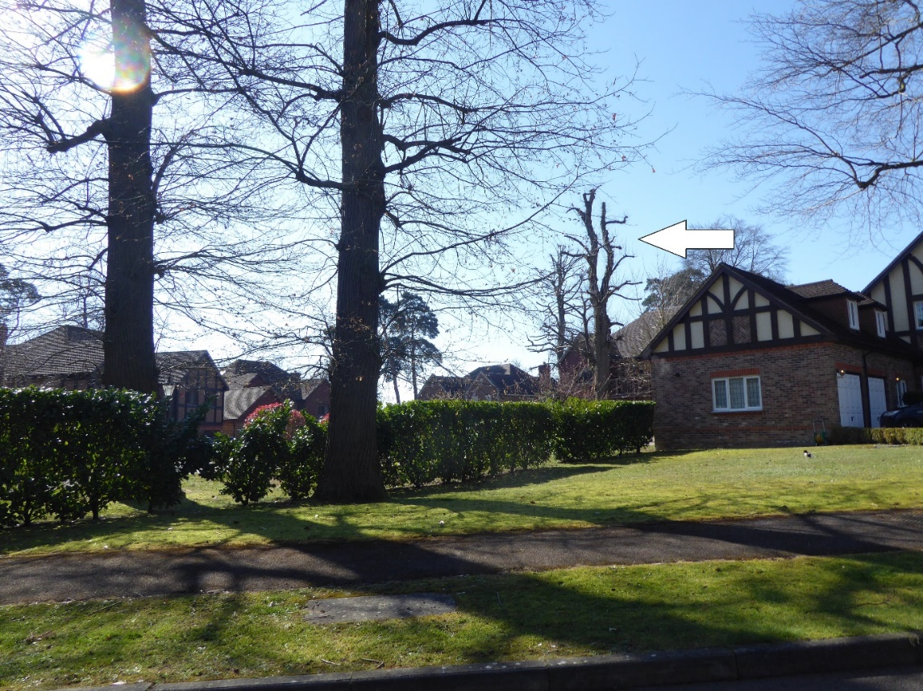However, a photograph made available to the Parish Council, does show the chestnut tree (arrowed) is a mature specimen that can be clearly be seen from Hancocks Mount road. It is also apparent that it has been subject to some recent aggressive pruning/ pollarding.

We note that it is the intention of the applicant to plant a replacement beech tree within 1 metre of the felled chestnut.

No indication is given about the size of the beech tree and the Parish Council believe this would not compensate for the loss of a mature chestnut tree.

Setting a precedent to fell a mature TPO tree and replace it with a young tree of a different species (that would then not be TPO protected) is not something we would encourage. It is to be hoped that the existing chestnut will recover from the previous (unauthorised) aggressive pruning.

It was not possible to view T2 and T3 (beech trees) recommended for crown lifting and neither were any photographs of these trees included in the application. We would **refer** this request for crown lifting to the Tree Team. The Tree Team may also want to follow up on the authorisation for the recent pruning of the chestnut tree.

The main concern of the Parish Council is the felling of the chestnut tree (T1) and in this regard we **STRONGLY** recommend that RBWM **REFUSE** this application

Yours sincerely

Michael Burn

Chair Planning Committee