

The Pavilion, Broomhall Lane, Sunningdale, SL5 0QS

1. 01344 874268 Email: info@sunningdaleparish.org.uk

[www.sunningdale-pc.org.uk](http://www.sunningdale-pc.org.uk)

Clerk: Ruth Davies

Paul Cross

Planning Officer

RBWM

Town Hall

Maidenhead

26 March 2020

Dear Paul

**20/00444: Greenwood the Covert Ascot SL5 9JS   
  
(T1) - Silver Birch - Fell. (T2) - Oak - Fell. (T3) - Twin stemmed Silver Birch - Fell. (T4) - Yew - Fell. (T5) - Goat Willow - Fell. (TPO 59 of 2003)**

The Parish Council is most concerned that this application and especially the request to fell the TPO oak tree, T2 sited on the boundary of the site which is directly in public view from Bagshot Road. The reason stated in the application for this oak tree to be felled is that *it is leaning over the public highway*. No other reason is given, and neither is there any independent professional arboricultural evidence or report supplied that states the age, condition or height of this oak tree.

However, as can be seen in the photograph below this oak tree appears to be a fine specimen.

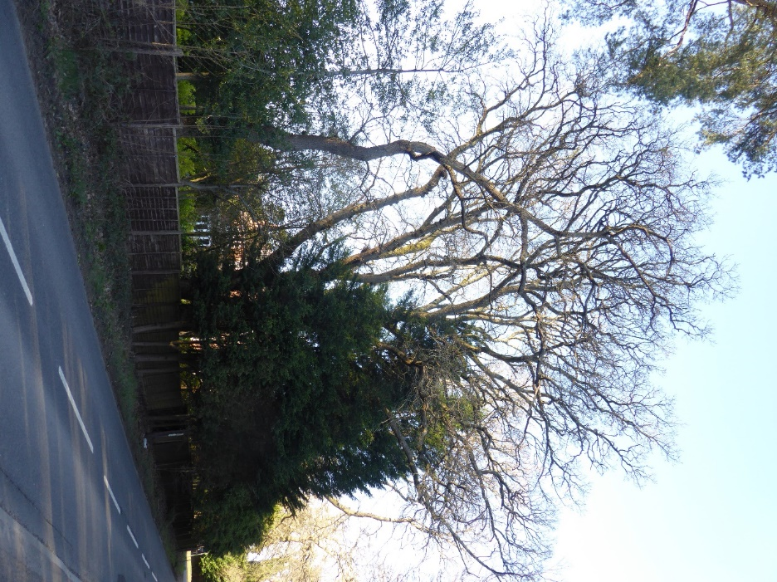

Any overhanging of branches into Bagshot road is negligible and those branches that are overhanging appear to be at a sufficient height to not interfere with any vehicles.

The Parish Council can see no reason for this tree to be felled. From the photograph it appears to be a fine, mature tree. A visit to the site would show that there are a large number of mature trees along Bagshot Road many of which have overhanging branches that are considerably lower and more extensive than this oak tree.

If ANY remedial work is required to this oak tree then, subject to a professional arboricultural report, we would anticipate that modest pruning of some of the overhanging branches may be recommended. The Parish Council therefore **STRONGLY OBJECT** to the felling of T2.

The Yew tree (T4) and the Silver Birch tree (T3) that are planned for felling can also be seen in the above photograph as they are positioned between the oak tree (T2) and the cul de sac road , The Cover shown is the distance. The application states that the Yew tree is dying and that the Silver birch is also dying as well as leaning over the road. Again, we can see little evidence of any dangerous overhanging branches.

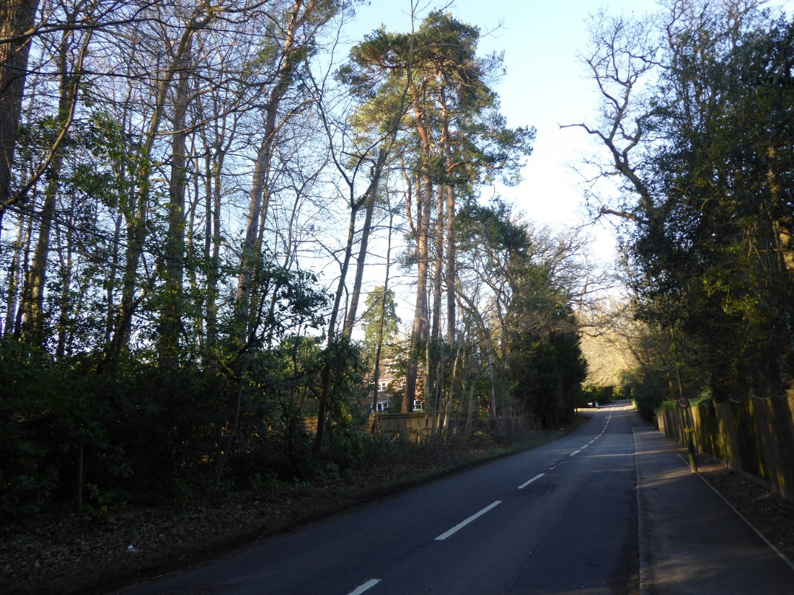

There is no public access to view the condition of the other trees recommended for felling, T1 (silver birch) and T5 (goat willow).

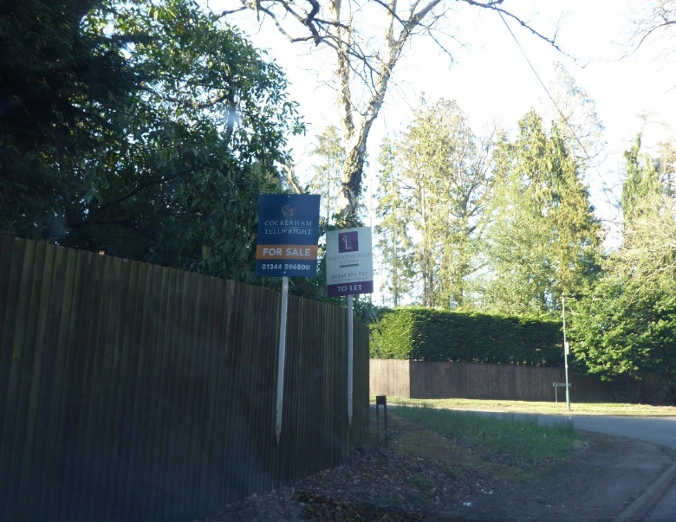We note also that there are for sale/ to let signs displayed outside this property.

Whilst it can only be conjecture it might be noted that removal of the TPO trees T2, T3 and T4 could give additional vehicular access to the plot.

The Parish Council request that this application be **REFUSED.**

Yours sincerely

Michael Burn

Chair Planning Committee