

The Pavilion, Broomhall Lane, Sunningdale, SL5 0QS

1. 01344 874268 Email: info@sunningdaleparish.org.uk

[www.sunningdale-pc.org.uk](http://www.sunningdale-pc.org.uk)

Clerk: Ruth Davies

Toby Fox

Planning Officer

RBWM

Town Hall

Maidenhead

26 March 2020

Dear Toby

**20/00433/TPO: White Walls Bedford Lane Sunningdale Ascot SL5 0NP**

**(T4) - Oak - Fell. (TPO 1 of 1957).**

The application states that the tree is in decline, presenting with holes up the whole of the trunk which have been created by wood boring insects.

However, under section 6 on the same application form in answer to the question ’is it diseased?’ the applicant states ‘no’. Hence there is some contradiction.

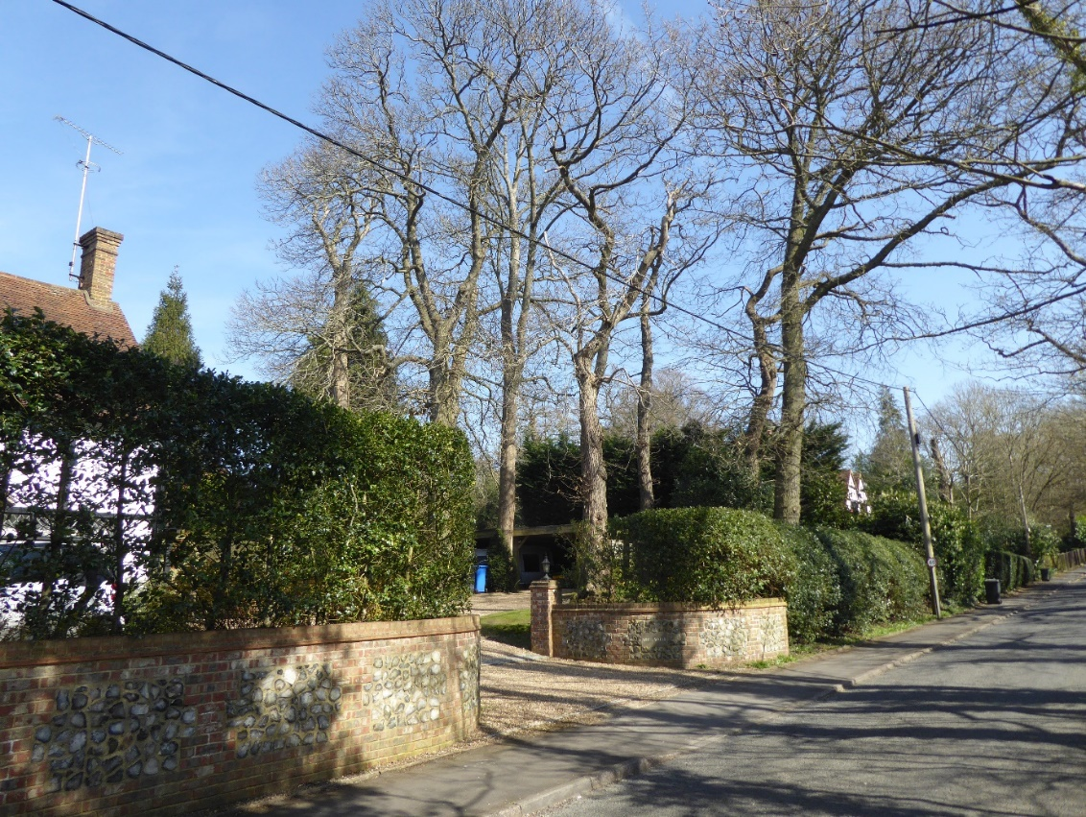  
Looking at this photograph T4 is probably the tree in the foreground which does appear to be in decline.

It would be helpful if the applicant could confirm this.

Yours sincerely

Michael Burn

Chair Planning Committee