

The Pavilion, Broomhall Lane, Sunningdale, SL5 0QS

1. 01344 874268

Email: info@sunningdaleparish.org.uk

[www.sunningdale-pc.org.uk](http://www.sunningdale-pc.org.uk)

Clerk: Ruth Davies

Adam Jackson

Planning Officer

RBWM

Town Hall

Maidenhead

26 March 2020

Dear Adam

**20/00379: Lime Tree Villas London Road Sunningdale Ascot SL5 0JN   
  
Details required by Condition 2 (Materials) and Condition 5 (Landscaping) of planning permission 19/01015/VAR for a Variation (under Section 73A) of Condition 2 (Approved Plans) to substitute those plans approved under 15/01752/FULL for 4 No. dwellings forming 2 pairs of semi-detached houses with associated parking, garages and amenity space following demolition of existing dwelling with amended plans (Allowed on Appeal).**

The landscape proposals for the front boundary as approved under application 15/01752/ FULL showed trees along much of the front boundary. Drawing FD-1285-55B submitted under Site Plans is shown below and illustrates the screening effect of this landscape proposal.

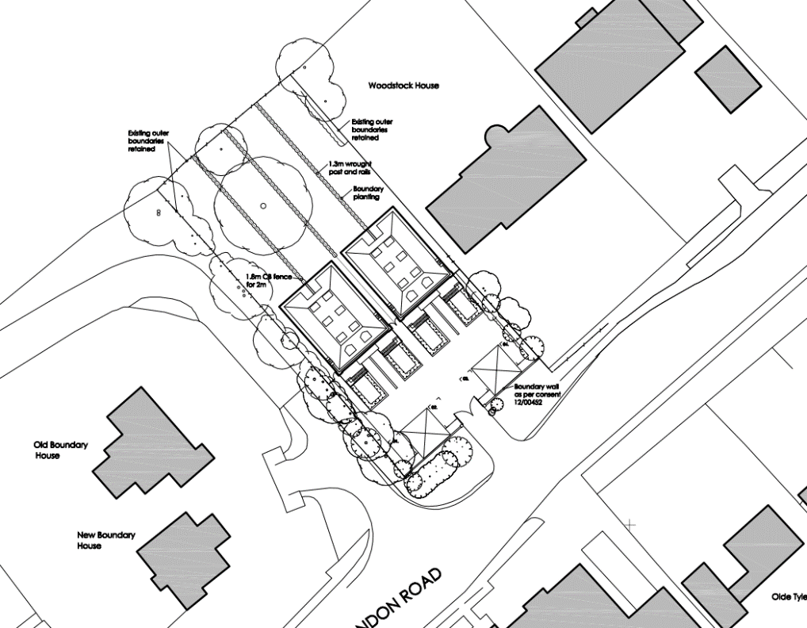

**15/01752 Approved on Appeal - Drawing FD 15 -1285 – 55B**

Although now only having a single access driveway, the boundary description still references a wall at the front.

Subsequent variations have also reinforced the landscape proposals approved under 15/01752.

Application 18/00337 was submitted to include a revised site layout. This was approved with the following Condition 6 on Landscaping: -

‘The details shown on drawing KEB17836-11A are approved as those required in connection with this condition’.

**detailed aerial view plan showing front boundary**

**18/00337 – Document Ref: KEB17836-11A**

NOTE: This schemestill references a boundary wall at the front.

The current application 20/00379 is similar to the approved variation 18/00337.

variation of aerial view of the site plan showing front boundary

**20/00379 Document Reference KEB17836-11C**

An additional 2 x Acer trees are now shown on the front boundary which is welcome, and the hedge design has been slightly reworked.

It is not clear from the proposed plan (KEB17836-11C) whether the boundary wall is still part of this proposal. The text on the drawing itself (‘Boundary Wall as per consent 12/00452’) now seems to have disappeared since 18/00337 - although the AutoCAD Tax comment still says ‘Boundary Wall as per consent 12/00452’ on the uploaded document.

Please can we have some clarity on whether the boundary wall is still included? Also, we would request a street scene showing the exact make-up of this front boundary. NOTE: This to include the proposed heights of the proposed Fagus sylvatica planting on this front boundary.

The 4 x separate planted areas at the front of each dwelling have also been reduced in width in comparison to 18/00337. They are now postage stamp size, and this represents more loss of green space.

As can be seen from the progression of this development. Originally the two very large buildings and more importantly the two garages in front of the building line were partly hidden by trees and a boundary wall in the approved scheme 15/01752.

Until such time as the above details are reviewed by RBWM the Parish Council request that this application be **REJECTED.**

Yours sincerely

Michael Burn

Chair Planning Committee