

The Pavilion, Broomhall Lane, Sunningdale, SL5 0QS

1. 01344 874268

Email: info@sunningdaleparish.org.uk

[www.sunningdale-pc.org.uk](http://www.sunningdale-pc.org.uk)

Clerk: Ruth Davies

Vivienne McDowell

Planning Officer

RBWM

Town Hall

Maidenhead

26 February 2020

Dear Vivienne

**Ref: Sunningdale Park, Larch Avenue, SL5 0QE – 20/00315**

The Planning Committee considered this application at its meeting on 25th February 2020 and **have major concerns** with elements ofthe **Construction Environmental Management Plan.**

According to their website – “Berkeley Homes are proud to be amongst the select group of companies invited to be Partners of the Considerate Constructors scheme”. Their code states: -

**Respect the Community**  
 **Constructors should give utmost consideration to their impact on neighbours and the public**

* Informing, respecting and showing courtesy to those affected by the work.
* Minimising the impact of deliveries, parking and work on the public highway.
* Contributing to and supporting the local community and economy.
* Working to create a positive and enduring impression and promoting the Code.

Our major concerns relates to **the impact of deliveries, parking and work on the public highway** refined in the following sections in the Plan:-

**vii) The routing of construction traffic; traffic routes**

Being a village parish with quite narrow roads, we have real concerns about the viability of the proposed transport routes to/from Sunningdale Park on the village roads.

The map shown in Appendix 1, does not take into account the narrowness and pinch points on some of these roads in particular Broomhall Lane.How can articulated 40 ft lorries negotiate these pinch points without compromising the safety of pedestrians walking along the pavement as well as other vehicles? The Parish Council believe this has the potential to be a major road hazard going forward. The following pictures illustrate these concerns.

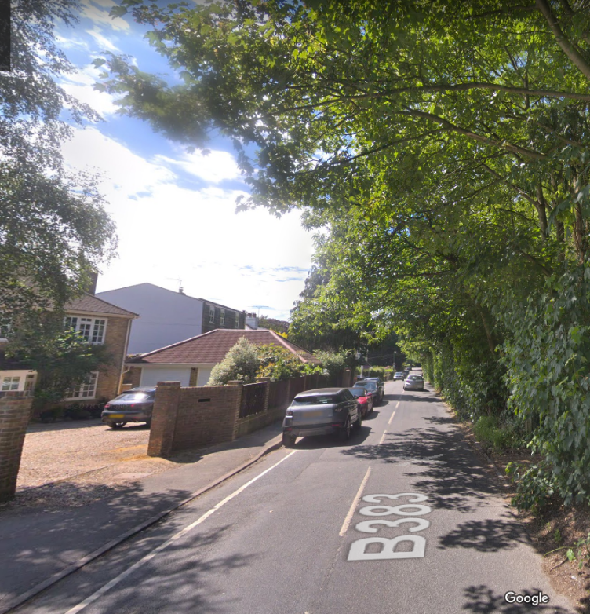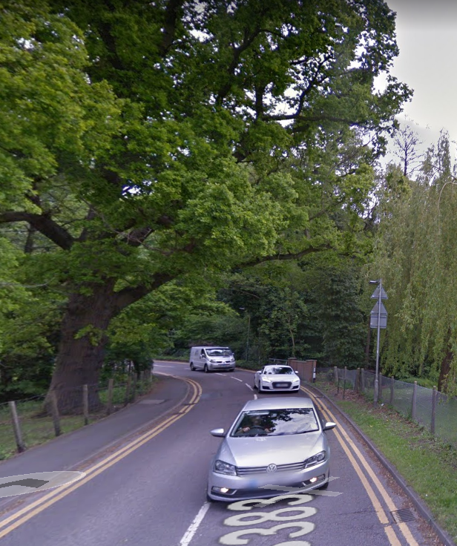

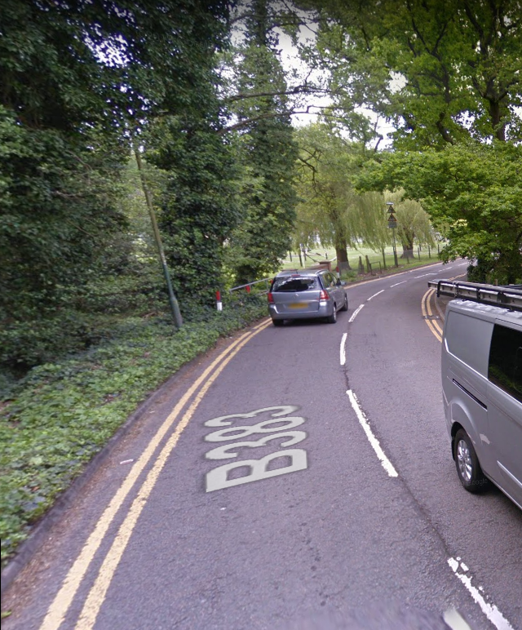

We are really concerned that the whole aspect of impact of construction traffic has not been fully appreciated either by the developer or RBWM.

We would urge RBWM to set up a suitable forum with the developer and the most affected parish councils to manage the impact of deliveries, parking and traffic on the local residents.

**xv) Working hours (including demolition and construction)**

The hours stated here are slightly longer than the accepted norm for ‘considerate contractors’ i.e. 8am – 6pm (Monday to Friday) and 8am – 2pm (Saturday).

The wording here makes no mention of deliveries. There is no mention of the actual Site Opening Hours nor any Quiet Hours.

Will the site be open before these stated ‘working’ hours for staff to arrive and for deliveries?

Please can this section concerning hours be clearer about all the activities on site and when they can take place?

Lastly, we are concerned that once this plan is signed off, there is no process for continued assessment or review of this Construction Environmental Management Plan as the development progresses.

This could be resolved by the creation of the forum referenced above which would enable the developer to get feedback on issues facing the residents and the ability to respond to them.

We ask you to **reject** this application.

Yours sincerely

Yvonne Jacklin

Chair Planning Committee