

The Pavilion, Broomhall Lane, Sunningdale, SL5 0QS

1. 01344 874268

Email: info@sunningdaleparish.org.uk

[www.sunningdale-pc.org.uk](http://www.sunningdale-pc.org.uk)

Clerk: Ruth Davies

Jo Richards and Harrison Moore

Planning Officer

RBWM

18 December 2019

Dear Jo and Harrison

**Site of Bluebells Restaurant and Bar London Road Sunningdale Ascot, also now known as Sunningdale Villas.**

The Planning Committee considered three applications for this site at its meeting on 17 December 2019, and **strongly objects** to all three applications.

Application 1: **19/03244/VAR** | Variation (under Section 73) of condition 19 (approved plans) to substitute those plans approved under 17/02204/FULL for the construction of a building to provide x 8 two bed flats, together with access to London Road and landscaping, following demolition of the existing buildings. | Site of Bluebells Restaurant and Bar London Road Sunningdale Ascot

Application 2: **19/03266/FULL** | New single garage for plot 5. | Sunningdale Villas London Road Sunningdale Ascot

Application 3: **19/03320/FULL** | Construction of six new Orangeries. | Sunningdale Villas London Road Sunningdale Ascot

These are in addition to another application for this site which we reviewed at a Planning Meeting on 27 August 2019 and also objected to:–

**19/02165/VAR** | Variation of conditions 3 (demolition of buildings - green belt) and 19 (approved plans) of application 17/02204/FULL to retain an existing building (building 2) and to substitute the approved plans with the amended plans for the construction of a building to provide x 8 two bed flats, together with access to London Road and landscaping, following demolition of the existing buildings. Sunningdale Villas London Road Sunningdale Ascot which was reviewed in August 2019. This is still awaiting a decision.

These various planning applications individually and in total attempt to expand the scope of the approved scheme for 8 two-bedroomed apartments **(17/02204).**

**Approved Scheme 17/02204**

This application took a year to be decided from July 2017 to July 2018. The scheme as originally submitted proposed 10 x 2-bed apartments with a provision of 16 parking spaces. This scheme was amended over the period of determination to be 8 x 2-bed apartments with a provision of 20 parking spaces.

There are no garages on the approved plan.

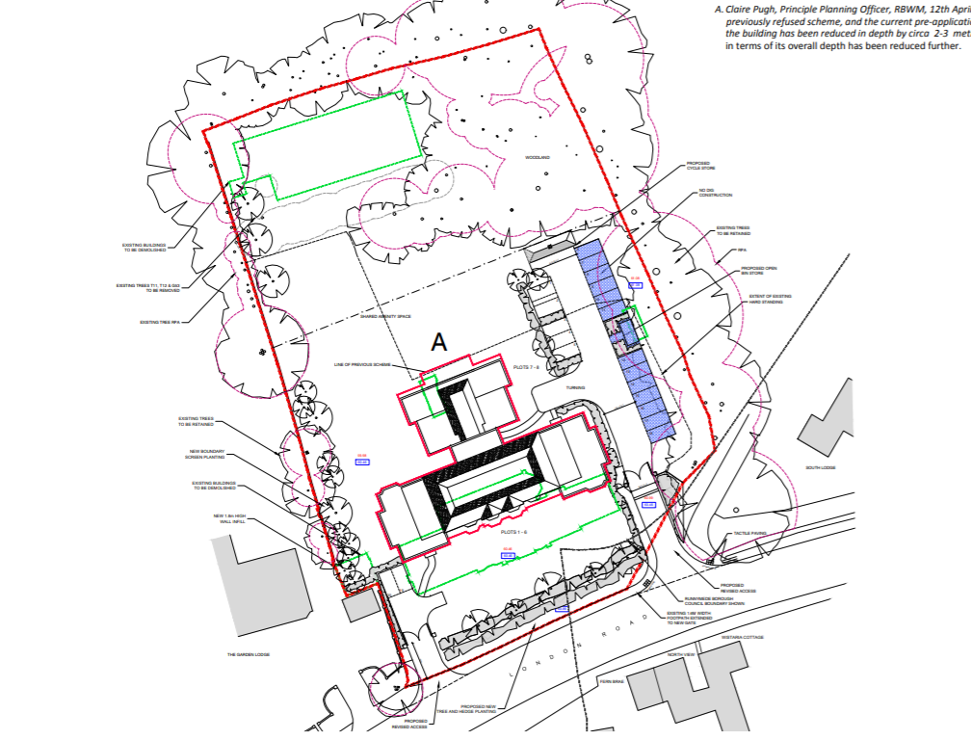

Approved scheme 17/02204 Site Layout

**Green belt – Openness**

This site sits in the Green Belt. The permitted development of eight two-bedroom flats was acceptable because of the reduced scale and massing and the lesser impact on the openness of the Green Belt than the originally proposed ten two-bedroom scheme.

A key element of achieving this acceptable level of openness was the reduction in the spread of development across the site. When considered along with the decrease in volume of development, ‘the final set of amended plans for application 17/02204 were considered not to have a greater impact on the openness of the Green Belt than the existing development’.

The data used to make this assessment was that the increase in floor space of 1.5% from 1076.5 m2 to 1092.5 m2 was acceptable given that the volume comparison showed an overall reduction in volume across the site of from 4248 m3 to 4098 m3 (Ref: 16-P1306-500C)

**Concept Landscape plan**

The approved sceme had a large area of amenity space at the front and rear. This was altered through planning application 18/02742, which approved a concept landscape plan (Ref:P989/002 Rev D). This landscape plan now shows individual plots having their own small gardens and a much reduced area of amenity space.

Interestingly the building which was marked the cycle store on the approved plan (17/00204) is now called a ‘proposed new garage’.

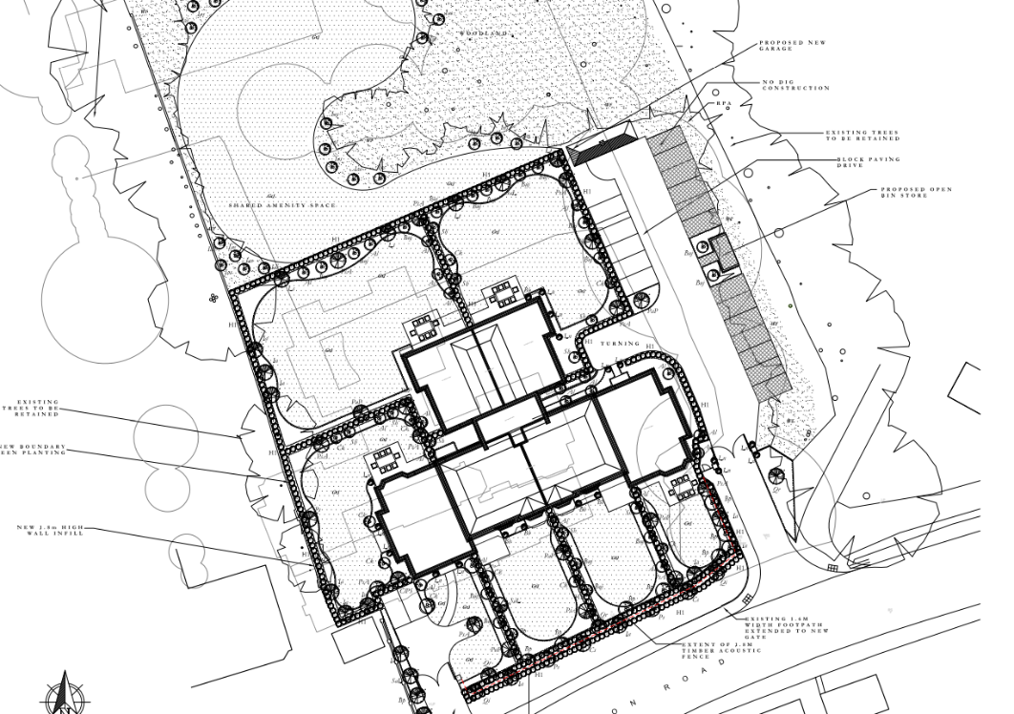

Concept Landscape plan

Ref:P989/002 Rev D

**Current Applications**

The applicant is now submitting a series of changes across a series of different Planning Applications which in total alter the approved plans to such an extent that these additions will have an impact on the openness of the site and therefore conflict with Green Belt planning policies.

**Application 19/03244**

This application covers a change to the structure of a bike and bin store as a Variation (Under Variation 73).

Plan 200G shows the request to relocate the cycle store from its current location and build instead a combined cycle and bins store in the location previously designated as an open bin store. The reason for this is not stated but you will see that Plan 200G now includes a gravel path running alongside the back of the gardens for plots 4 and 5, with further parking shown behind Plot 5.

This is contrary to the approved Concept landscape plan (for which no further changes have been requested).

One of the issues that the proposed relocation of the combined cycle and bin store site creates is that this building requires proper foundations which will damage the RPAs of TPO trees on the neighbouring site. We concur with Helen Leonard’s comments on this application.

Finally, it is interesting to note that both plans show Existing Building 2 as being retained – when this is still awaiting a decision under planning application 19/02165.

The changes can be seen in the pictures below, with a request to approve version 200G.

Existing Building 2

Bin Store

Cycle and Bin Store

Cycle Store

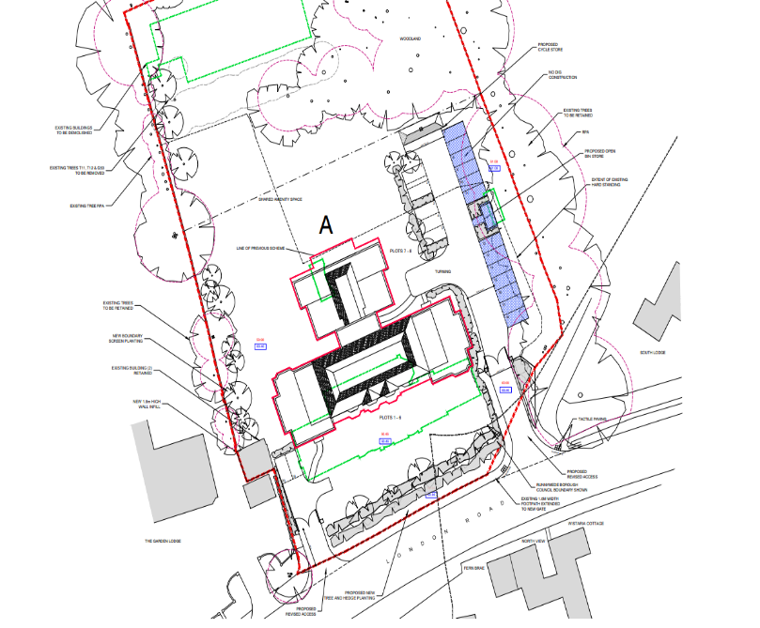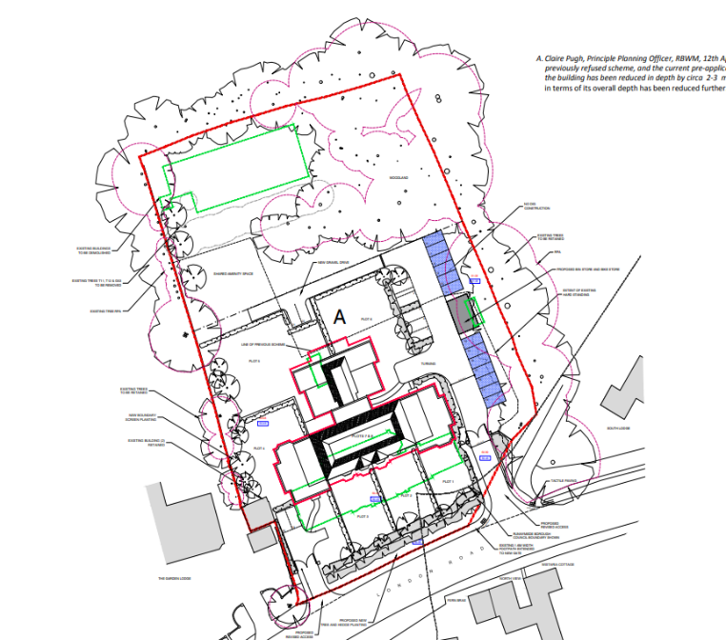

Doc.16-P1306- 200F

Doc.16-P1306- 200G

**Application 19/03266**

This application (now under the name of Sunningdale Villas) shows for the first time the reason for the requested change to the location of the cycle store, namely the addition of a garage at the end of plot 5.

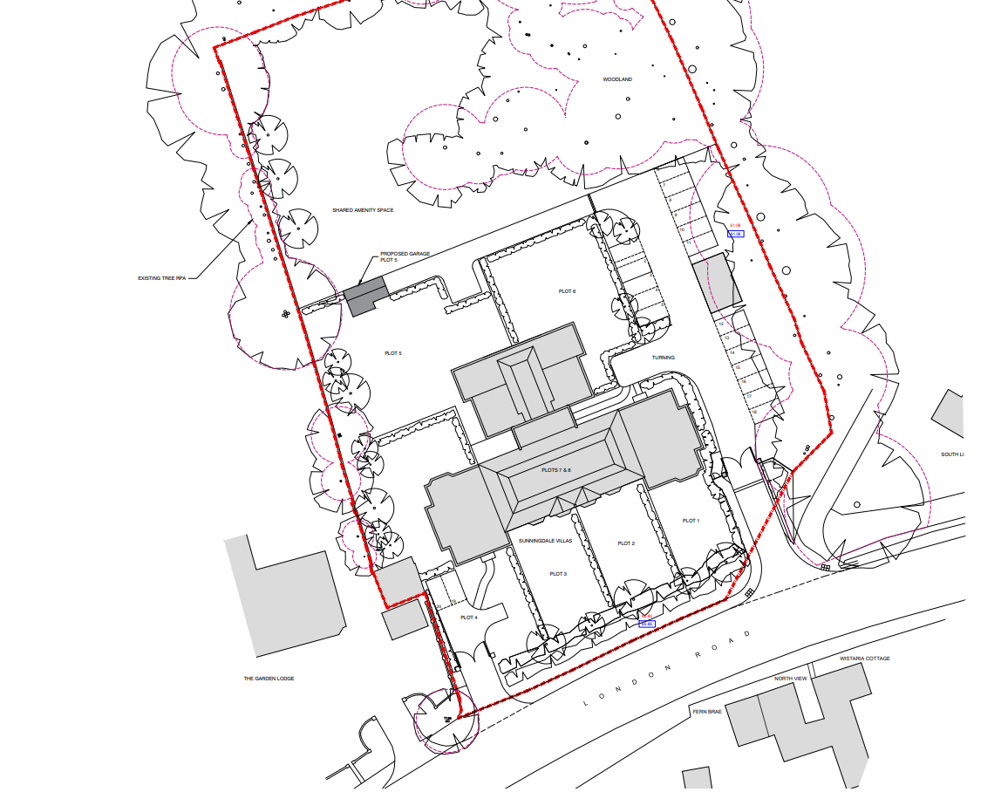

Site Layout 19/03266

Showing addition of garage

One of the documents associated with this application (16-P1306-606) refers to a garage for Plot 7 when other documents and the application itself refers to plot 5. This might be an administrative error – or a slip which might lead one to conclude the reason for retaining Existing Building 2 (Application 19/02165) is with a view to turning it into or replacing it with a garage at a later date (if it’s retained).

However, this now represents increased area and volume on this site. Approval of this plan would set a precedent for other garages on this site.

**Application 19/03320**

This Application is for six new Orangeries. Although this was reviewed at our Planning Committee meeting, we note that this application has now been withdrawn. Clearly the addition of six extensions, all of which are habitable space would have added significantly to the area and volume of the site and therefore the openness of the development in the Green belt.

**In Summary**

We are concerned that the application of numerous individual changes to the Approved plan could potentially mask the true totality of these changes which, had they been considered together, would have exposed the intention of the applicant to expand the scope, area and volume to such a degree that the development as a whole would now be considered ‘unacceptable development’ in the Green belt.

We therefore **strongly object** on the basis of:

1. “Acceptable uses and development in the Green Belt” Relevant Policies - **Local Plan GB1, GB2’**
2. These applications result in a development which no longer complies with paragraph 89 of the NPPF as appropriate development in the Green Belt.

We ask that these applications be called to the Windsor Rural Development Panel should the planning authority be minded to permit.

Yours sincerely

Yvonne Jacklin

Co-Chair Planning Committee