

The Pavilion, Broomhall Lane, Sunningdale, SL5 0QS

1. 01344 874268

Email: info@sunningdaleparish.org.uk

[www.sunningdale-pc.org.uk](http://www.sunningdale-pc.org.uk)

Clerk: Ruth Davies

Zarreen Hadadi

Planning Officer

RBWM

31 January 2020

Dear Zarreen

**19/03557 - 37 Coworth Road Sunningdale Ascot SL5 0NX**

**Single storey rear extension, part garage conversion into habitable accommodation, alterations to fenestration and new vehicular access with dropped kerb**

The Planning Committee reviewed this application at the meeting on Tuesday 28 January and had the following **objections**:

* the proposed application is an “in filling” of the space around the property to a level that impacts directly on the neighbouring property and contravenes NP/DG2
* as a semi-detached property, the proposed development has a responsibility to comply with NP/DG3 – to deliver a design that sits comfortably with the existing built environments
* loss of the current garage to the side of the property for parking and the provision of parking for the property by significantly extending a dropped kerb to the front does not provide adequate parking for the proposed size of property nor for visitors (shown below)

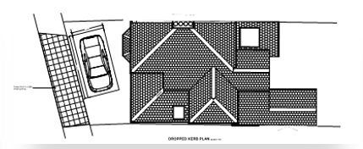

The council also notes the comments from the neighbouring property regarding loss of light due to the rear extension and requests that this application is **refused.**

Yours sincerely

Anne-Catherine Buxton

Chairman of the Council