Sunningdale Parish Council Logo

The Pavilion, Broomhall Lane, Sunningdale, SL5 0QS

1. 01344 874268 Email: info@sunningdaleparish.org.uk

[www.sunningdale-pc.org.uk](http://www.sunningdale-pc.org.uk)

Clerk: Ruth Davies

Jo Richards

Planning Officer

RBWM

Town Hall

Maidenhead

29 January 2020

**19/013547 Land at Lady Margaret Cottage Charters Road Sunningdale Ascot**

**Construction of a detached four-bedroom dwelling with associated parking and landscaping.**

Dear Jo

The Parish Council planning committee reviewed this application on Tuesday 28 January and **strongly object** to this proposed development.

This application is not significantly different to the previously refused application (19/01740), despite the applicants planning statement that this application addresses the reasons for the previous refusal. For reference the committee would direct your attention to the letter of objection the council sent for application 19/01740 and your own reasons for refusal.

The council’s **strong objections** to this current application are as follows:

## Ridge height, size and bulk

The applicant has changed the ridge height method of measurement to reference this to the floor level. However, conversion shows the previous ridge height was 8.85 metres from floor level and the new development 8.15 metres from floor level. A total reduction in ridge height of 0.7 metres or 70 centimetres – imperceptible to an individual without the relevant measuring equipment.

The council once again refers to the refused application for Taymount (17/ 02721) development on Lady Margaret Road. Taymount was Refused at Appeal on February 12th, 2019. The Inspector stated that the proposed Taymount development would result in a significantly bulkier building than those to either side and along this side of the street and that it was not compatible with the street scene. Taymount had a ridge height of 9.1 metres or 0.95 metres higher than this application.

Side view sketches of the plan of the house with outlines showing rejected plan

The stated lowering of the floor level by 0.15 metres or 15 centimetres also has a neutral effect on mitigating the refusal reason by RBWM:

* *by reason of its overall scale, height and proximity to the north-west boundary of the site would have an over dominant, overbearing and unneighbourly impact on the adjacent property The Garth. (contrary to saved Policies H10 and H11 of the Royal Borough of Windsor and Maidenhead Local Plan 1999 (Incorporating Alterations adopted June 2003) and contrary to NPPF paragraph 127. The proposal would also fail to comply with policy SP3 of the Borough Local Plan Submission Version.*

The proposed scale of the build has not significantly altered. The CIL statements as completed by the applicant shows the proposed property will have 295 sq. metres of living space whilst retaining the existing garage at 84.5 sq. metres, totalling 379.5 sq. metres. 19/01740 had 411 sq. metres of which circa 60 sq. metres was the garage and 40 sq. metres was third floor accommodation which has now been removed in the current application – although with only a 0.7 metre reduction in ridge height.

To determine the impact of the application for bulk and scale however, the comparison needs to be made of the two buildings minus the garage and third floor, which is then 295 sq. metres for the current application and 311 sq. metres for 19/01740 – the loss of a 4m by 4m space and not viewed as a significant reduction by the parish council.

|  |  |
| --- | --- |
| 19/03547 | 19/01740 - Refused |
| Aerial view plan showing the plot | Aerial view plan showing the plot |

The propose property will still dominate, overlook and completely dwarf Garth cottage which is a bungalow as shown below in the comparison of the new application and the refused application elevations towards The Garth.

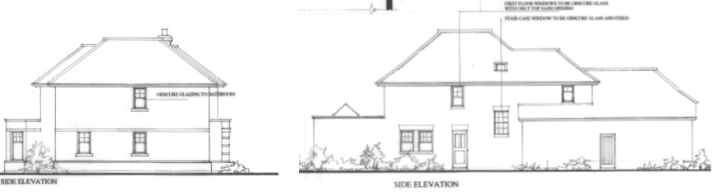

19/01740 - Refused

19/03457

## Townscape assessment

Given the Townscape assessment of a ‘Leafy Residential suburb’ there are concerns about the area of garden amenity being very small. The proposed building will dominate the site with the built form including buildings, garage and access areas estimated at occupying more than 75% of the plot. The image below shows the current garden amenity and the driveway to the existing garage which is now to be retained. To put a building of the size proposed would contravene NP/EN3.

Photograph of rear garden of Lady Margaret Cottage.

The Parish Council believe this proposed development conflicts with Policies NP/DG1.1, NP DG1.2, NP/ DG2.1, NP/ DG2.2, NP/DG3.1, NP/EN2.1 and NP/EN3 of the Ascot, Sunninghill and Sunningdale Neighbourhood Plan (NP) and request that RBWM **REFUSE** this application given the effect of the development on the character and appearance of the area.

Yours sincerely

Anne-Catherine Buxton

Chairman of the Council