

The Pavilion, Broomhall Lane, Sunningdale, SL5 0QS

1. 01344 874268

Email: info@sunningdaleparish.org.uk

[www.sunningdale-pc.org.uk](http://www.sunningdale-pc.org.uk)

Clerk: Ruth Davies

Zarreen Hadadi

Planning Officer

RBWM

31 January 2020

Dear Zarreen

**19/03426 - 14 Cedar Drive Sunningdale Ascot SL5 0UA**

**Single storey front extensions with new pitched roof over, part single, part two storey side/rear extension, alterations to fenestration. pergola and detached outbuilding.**

The Planning Committee reviewed this application at the meeting on Tuesday 28 January and had the following **objections**:

* contravention of NP/DG3.3 which requires garages to be set back from the building line
* this application is for a temporary structure of a Pergola, this is to provide “garaging” for cars and therefore must be classed as a garage structure, whether temporary or not and in contravention of the neighbourhood place
* overall scale of the proposed expansion is out of keeping with the neighbouring properties which share a drive passing the proposed increment to the frontage and parking facilities
* the proposed expansion to the rear also reduces the green space as provided by the garden as shown below

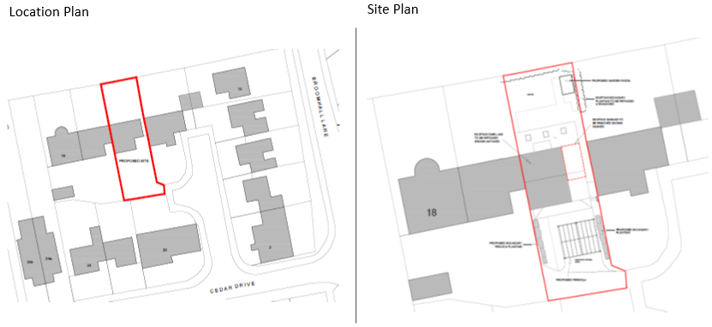

The council also notes the comments from the neighbouring property regarding loss of light due to the rear extension and their request that the roof line is amended to mitigate the impact on their property and requests that this application is **refused.**

Yours sincerely

Anne-Catherine Buxton

Chairman of the Council